The main purpose of the research is to development of a robotic inspection system for early detection and locating of biotic and abiotic stresses in greenhouse crops.

This is a corporate project to three research centers: Agricultural Research Center (ARO), University of Maryland (UMD), and Purdue University.

UMD developed an advanced detection algorithm based on selected channels of a hyperspectral camera, using advanced image analysis for early detection of TSWV disease based on 'outlier removal auxiliary classifier generative adversarial nets' (OR-AC-GAN) algorithm was developed at the University of Maryland, representing an expert center for disease detection.

Purdue University developed an algorithm that predicts the spreading of diseases, based on the result from the UMD algorithm, and decide what is the next point of sampling. Purdue also developed the Collaborative control system to guide the robotic system in performing the early disease detection task.

In ARL(Agricultural Robotic Lab at ARO), the robotic platform (figure 1) has been developed that fits to drive in a greenhouse, carry robotic manipulator, contain inside motors, a battery, sensors, PC that controls all the robot aspects and other components.

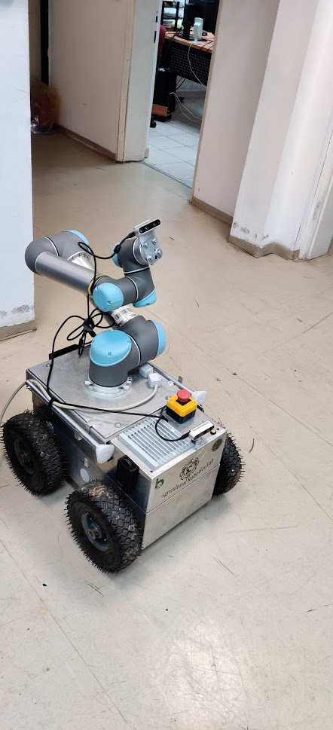

Figure 1- Mobile Robotic Platform

The body of the mobile platform is made from an aluminum sheet to provide strength and keep the weight low.

A 24V 20AH battery-powered two pieces of DC motor + worm gear ECM250/030 which can provide 22Nm @ 75 RPM each, that drive four 20mm shafts with wheels which on the two back shafts are mounted two encoders in a resolution of 32 pulses per cycle. Arduino Mega microcontroller receives and process the data from the encoders and command Roboteq AX3500 motor driver via serial communication. The microcontroller can receive the commands to drive the platform from two options: Via Xbox controller or via Intel NUC5i7RYH that used as the processing center of the platform.

SLAM and 3D mapping algorithms were developed in ARL as well as autonomous real-time navigation algorithms using Intel RealSense D435i- stereo depth camera which includes also IMU.

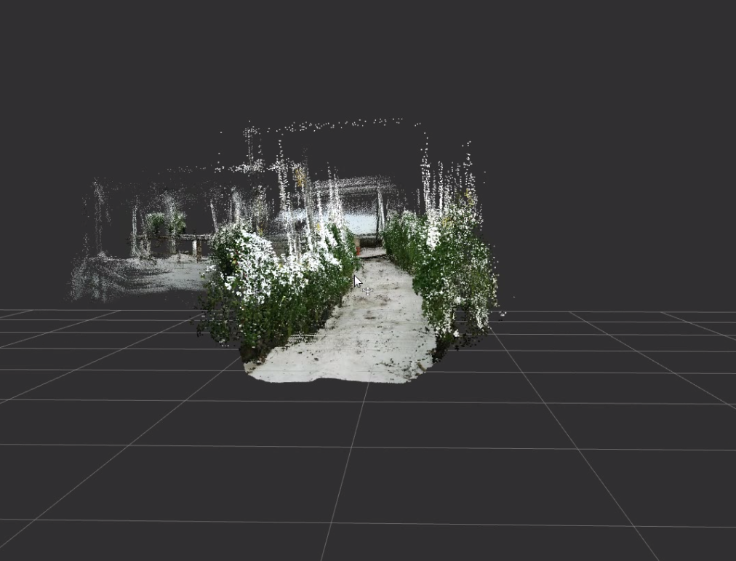

Figure - Greenhouse 3D map

The stereo vision in the IR field and using an IR projector for places with poor lights conditions. RealSense camera also has an RGB sensor for visualization. Inside the RealSense, a processor makes the calculations and create the depth map, As a result, it reduces the work from the NUC PC.

A ROS (Robot Operating System), is installed on NUC PC, set of utilities and libraries for implementing all different kinds of the functionality on the robot. As to create 3D and 2D maps, SLAM (Simultaneous localization and mapping), control the manipulator, communicate with the Arduino and other peripherals, and communicate with other robots and remote control units such as Purdue University and the UMD.

in order to navigate autonomously, the navigation algorithm creates, using the depth camera, 2D map with obstacles and free space where it can drive through.

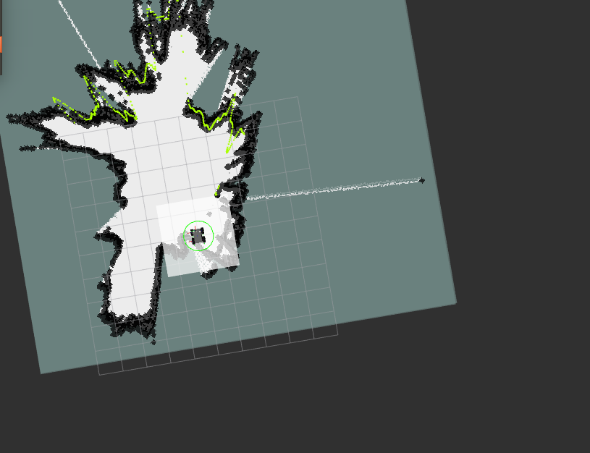

Figure 3 - 2D map for autonomuos navigation

On the top of the mobile platform is mounted an industrial manipulator (UR 5) which has six DOF and carries the spectral cameras that will detect diseases at the crop.

To Pepper leaf identification, an Intel RealSense D435 depth camera was mounted on the manipulator EE.

Pepper detection is done as follows: Once the platform reaches the detection point, it stops. The arm movement and foliage detection algorithm identifies the platform orientation with respect to the path and brings the platform into the initial detection mode. In this mode, the camera is parallel to the line of peppers and begins the process of plant identification. Detection is done by combining the depth and color features of the camera. The camera takes a picture and creates a mask where only the pixels that are up to 1.5 meters away from the camera enter it.in parallel it's converting the RGB image into HSV image and filtered by predetermined values, the filter passes only green pixels. For the pixels that passed the initial color filter and the distance filter, the pixel centers are calculated and only a consecutive pixel group passes the filter, so in case there are noises or other leaf edges they do not pass the filter. Then for the rest of the pixels, the center of mass of the color is calculated. Since the center of mass is calculated in 2D (X and Y axes), the point must also be found on the Z-axis. This process is also for the highest and lowest point in the plant.

After identifying the center and endpoints of the plant, the scan points are computed according to the following formula:

- For the top point: a point is taken at a distance of 30 cm and at a 45-degree angle above the top point of the plant

- For the middle point: a point is taken 30 cm away and is parallel to the central point of the plant

- For the lower point: a point is taken at a distance of 30 cm and at an angle 45 below the lower point of the plant.

After calculating these points, the arm starts moving first to the upper point, then to the middle, and finally to the bottom. The arm's motion algorithm is RRTSTAR.

As the arm moves, the camera continues to scan and check for any obstacles along the way, making sure the arm does not get stuck in the plant or any other obstacle.

A collaborative human-robot control algorithm was also developed to guide the robotic system in performing the disease detection task, implemented on the robotic platform. The robotic platform is located in Israel and controlled in real-time using the collaborative control system (HUB-CI) algorithms that developed at Purdue University. Commands, images, and data transferred between these two locations, representing a system controlled by a farmer from a remote location.

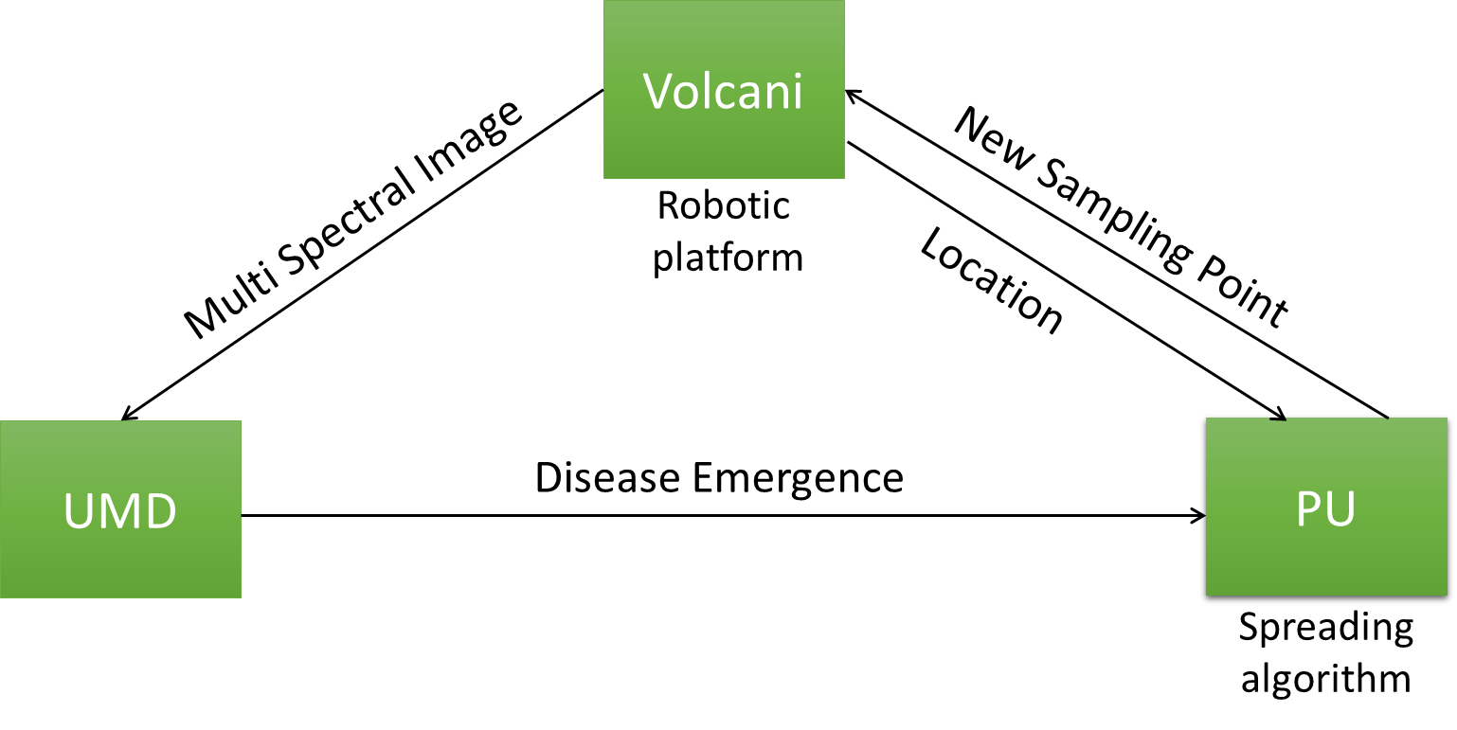

Figure - Concept of Operation